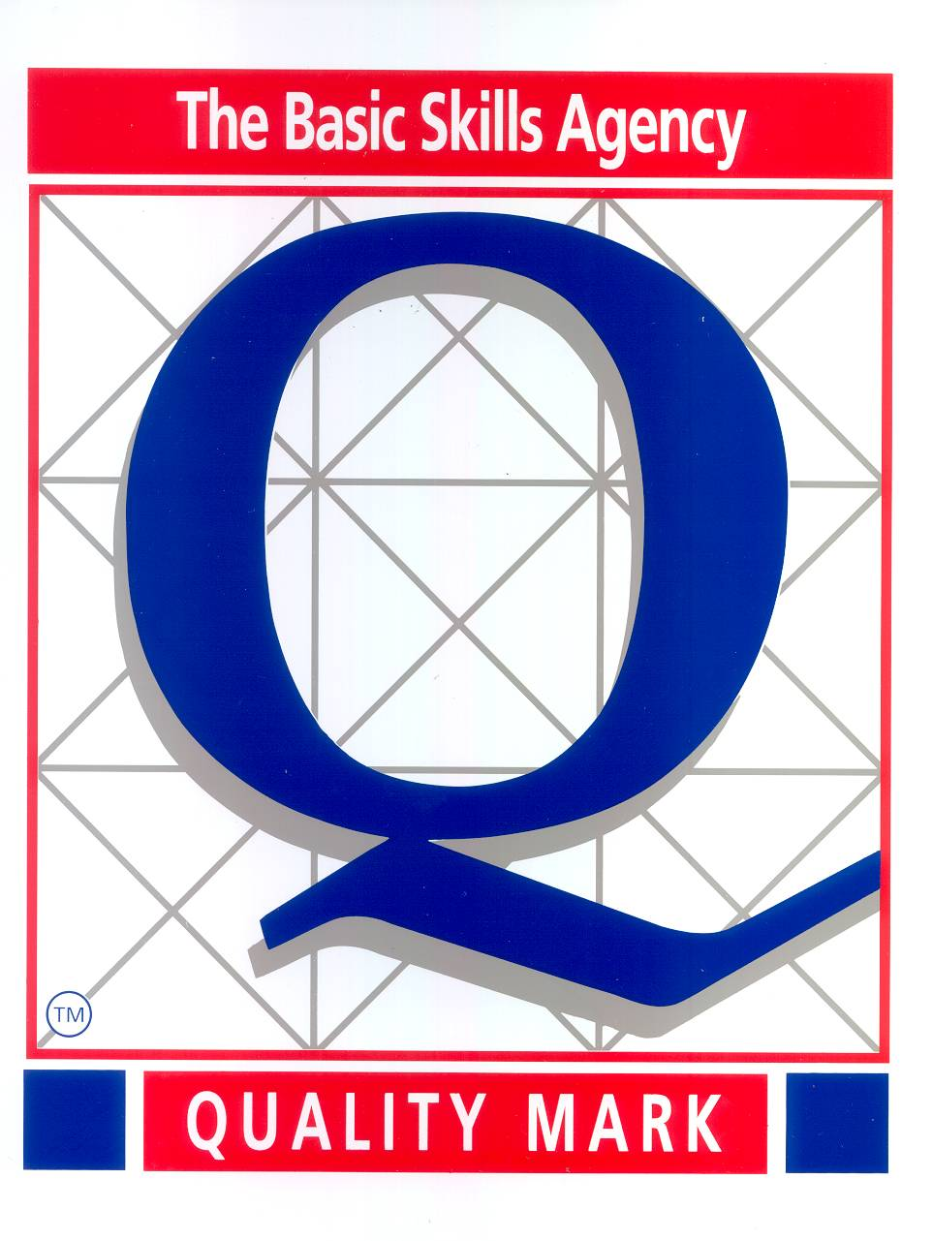

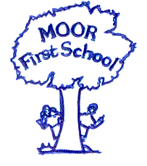 Moor First School

School Lane

Biddulph Moor
Stoke on Trent. ST8 7HR
Co- Headteachers: Mrs. S. J. Mayes & Mrs V Atherton
Tel. No. 01782 512350

e-mail: headteacher@moor.staffs.sch.uk.

3rd September 2021

Early Years Foundation Stage Framework and the recent changes.

Dear Parents/ Carers,

We are writing to you to give you an overview of the Early Years Foundation Stage Framework and to inform you of the recent changes that come into effect this September.

What is the Early Years Foundation Stage Statutory Framework?
The Early Years Foundation Stage (EYFS) statutory framework is a government document that all schools and Ofsted-registered early years providers in England must follow. It sets standards for the learning, development and care of your child from birth to 5 years old. The standards ensure your child will learn and develop well and are kept healthy and safe.

What will my child be learning?
The EYFS framework outlines seven areas of learning and development and educational programmes. There are three prime areas of learning, which are particularly important for your child’s development and future learning:
Communication and Language (CL)
Personal, Social and Emotional Development (PSED)

Physical Development (PD)

There are four specific areas of learning, through which the prime areas are strengthened and applied:
Expressive Arts and Design (EAD)
Literacy (L)
Maths (M)
Understanding the World (UtW)

Miss Whittaker and Mrs Butler will consider your child’s needs and interests to plan challenging and enjoyable activities and experiences.

How will my child be learning?
The EYFS framework identifies the essential role of play in your child’s development. It is through both child-led play and play guided by an adult that your child will develop confidence and relationships with others. Through play, our Early Years’ staff will help your child to extend their vocabulary and develop their communication skills. The EYFS framework identifies three characteristics of effective teaching and learning:
Creating and thinking critically
Playing and exploring
Active Learning

A greater focus on teaching specific skills will occur as your child progresses through their Reception year, which will help them to prepare for Year One.

How will I know how my child is doing?
Our Early Years’ staff will use their professional knowledge to understand your child’s level of development. If we have any concerns about your child's progress, we will discuss these with you.

Three formal assessments take place during the EYFS:
Two-Year Progress Check (this will happen between the ages of 24 to 36 months)
Reception Baseline Assessment (at the start of the Reception year)
Early Years Foundation Stage Profile (at the end of the EYFS)

Discussions at Parents’ Evenings will inform you on how your child is progressing. At the end of the academic year, a report will be given to you to inform you of your child’s progress and whether they have met or are continuing to work towards their early learning goals (ELGs). There are 17 ELGs your child is expected to achieve by the end of the EYFS.

The changes to the Early Years Foundation Stage Framework

The Early Years Foundation Stage (EYFS) has been reformed and there is a new EYFS framework that all schools and settings are required to follow from September 2021. These national changes have been made to better support all pupils’ learning and development. It is also the aim that the new framework will better prepare pupils for the transition into Key Stage 1.

There are some elements of the EYFS that have not significantly changed and some that have.

Below are some of the key points from the new EYFS reforms that include relevant changes:

Early Years staff will be spending less time on large amounts of written observations and assessments for evidence collection. This means they can spend more time supporting and engaging with the children and their learning and development needs.

Pupils will no longer be assessed against statements from an age band category. Instead, staff will use their experience and knowledge to monitor if a child’s learning and development is on track for their age.

The early learning goals at the end of reception have been changed to become more clear and easier to understand. Staff will use their judgements to assess if pupils have met these goals at the end of the EYFS and inform parents/carers.

There is an emphasis on improving pupils’ language and vocabulary through increasing opportunities for conversations, reading of a wide range of books and holding discussions around activities in other areas of learning.

Literacy and numeracy skills focused on in the EYFS have been adapted to better match up with the National Curriculum that starts in year 1.

There is no longer an exceeding judgement at the end of Reception. Pupils will instead be challenged to have a greater depth and understanding of ideas.

Safeguarding and welfare of pupils is still of utmost priority, with the added mention of teaching pupils about the importance of good oral health and how to keep teeth clean and healthy.

We hope that this has given you an insight into how/what your child will be learning this academic year.

If you have any questions, please do not hesitate to ask.

Kind regards,

Miss Whittaker and Mrs Butler

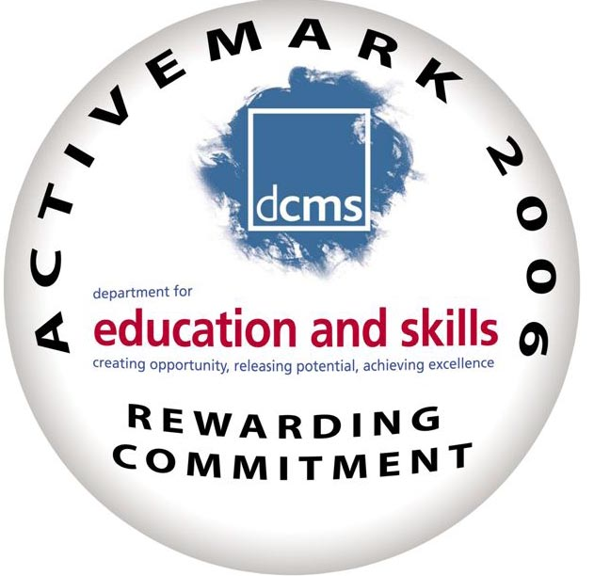
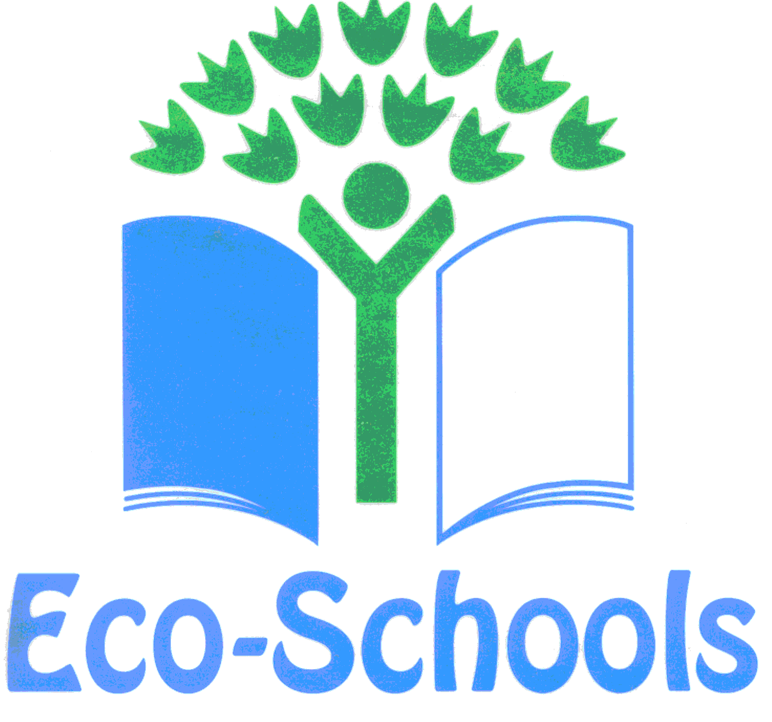Staffordshire County Council

