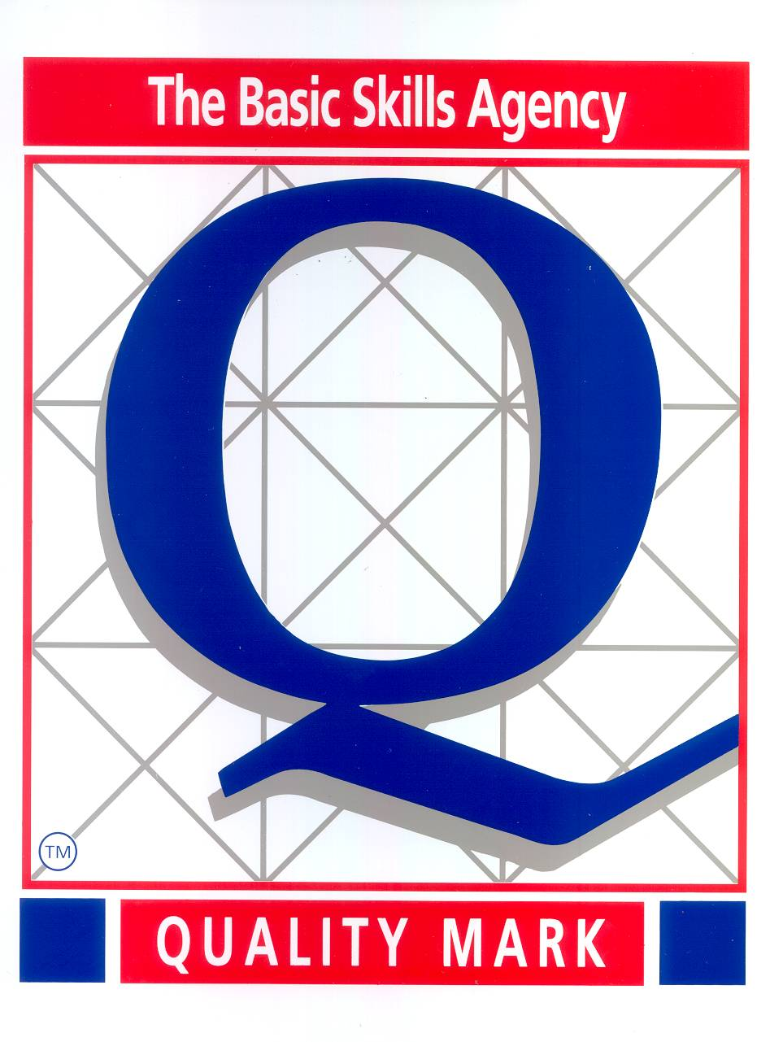

 Moor First School

School Lane

Biddulph Moor
Stoke on Trent. ST8 7HR
Co- Headteachers: Mrs. S. J. Mayes & Mrs V Atherton
Tel. No. 01782 512350

e-mail: headteacher@moor.staffs.sch.uk.

28th June 2021

Dear Parents,
We are coming to the end of the Summer term. As we are all aware this year has not been the greatest, but we want to send the year 4’s out with a bang!
Unfortunately, we are limited to what we are allowed to do this year, but we still want it to be special and memorable. We would love your support.
The ‘Tuckshop’ are very kindly buying all the school an ice-ream and providing each class with £50 to buy food for class parties. Usually some of you wonderful parents go and buy the food for us and help on the day. Due to restrictions, we aren’t able for you to do this.
We are planning a water fight so if you could donate water bombs this would be fantastic. The sooner they come in the better, as we have to isolate them.
Mrs Kirby is planning to bake and complete art crafts with the year 4’s, we are asking for a donation of £5 for the purchase of the ingredients etc. to be paid via ParentPay, it would really be appreciated. However, if you are having any difficulties in paying, please let the office know as soon as possible. In line with the Governors’ policy on payments and remissions, no child will be excluded through an inability or unwillingness to pay, but if we don’t receive enough donations, we will have to limit the activities planned.
This is a rough outline of additional events that we are planning, it has not been finalised so things may vary:-
Water fight
Cinema time
Golf/rounders/team games
Bottle flip competition
We may be asking for children, if they wish, to bring in skateboards, scooters, bikes, walkie-talkies, remote control cars.
Please could their hoodies be sent into school Monday 5th July so we can take a memorable photo for them to keep. In addition, a reminder for baby photos please and any during their time at Moor First!
If you have any questions or wish to discuss anything please contact the office and one of us will get back to you.
Thank you again so much. We really want to have some fun (not so sure with Mrs K doing art-haha!)

Kind Regards!

Mrs Atherton, Miss Lovatt and Mrs Kirby

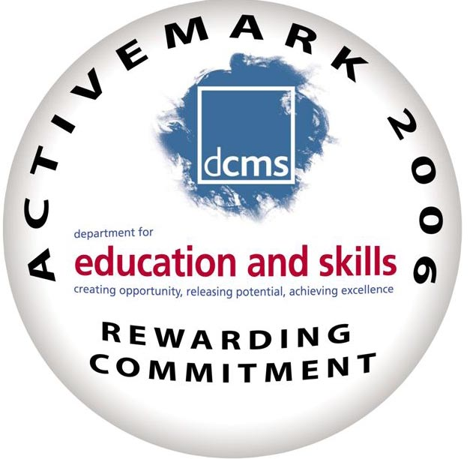
Staffordshire County Council

