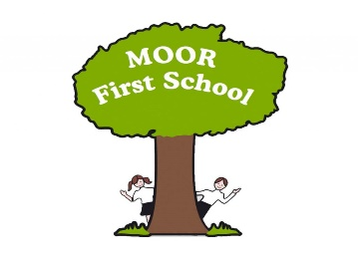
Vision, Mission, Values and aims.
(Revised June 2021)

Our vision:

‘Together we unlock potential and learn for life’

Our Mission, Values and Aims:

Moor First School works in partnership with parents, children, governors and the community to provide pupils with a first-class education and start in life. Moor First School fosters a lifelong enthusiasm for learning by creating real and meaningful experiences, which motivate and inspire. We equip children with the skills to learn throughout life and to strive for excellence in their work, relationships and friendships. We promote safety and the personal growth and development of all children, teaching and practising acceptance and inclusion for those of all backgrounds, abilities and beliefs.

Aims:
At Moor First School we aim to:
- Provide a stimulating framework under which children will progress according to their own abilities and needs whilst achieving their full potential within, and beyond the Foundation Stage/National Curriculum through an experience based, cross curricular approach to learning; where they have the desire to learn and find out more.
- Develop independent learners who are aware of their own progress and take responsibility for achieving their own targets.
- Promote self-discipline and to help our children to appreciate that courtesy, good manners and consideration for others, are good qualities.
- Encourage each child to take a pride in their work, and strive towards excellence, leading towards an awareness of their own worth in society.
- Develop a sense of awareness of equal opportunity for all regardless of gender, race, belief or ability.
- Promote a partnership between home, school and the wider community.
- Use our locality of Biddulph Moor as a starting point for learning and expose children to wider cultural experiences and British Values.

Values:
We encompass these six school values below through super hero characters:
Honesty, Respect, Confidence, Responsibility, Independence and ambition (aiming high.)

Our School Motto

Manners cost nothing; respect all,
On task all the time; ready to learn,
Only our best is good enough,
Responsible and honest,
FIRST school rules to reach our targets in life!

